Week 1 Notes - Introduction to Python

Thanks for coming to class today! Please read these notes to review what we learned, along with some helpful examples!

Note: Please help us with your / your student’s names! We are trying our best :D

# Coding in VSCode (Visual Studio Code)

* We had almost no problems with this, but just in case, the instructions are in the email sent out on October 7th.
* We set up a folder called the **coding workspace** and inside, the **intro units** folder. We created a file **main.py** within the intro unit folder.
* Running the code automatically saves the code and runs it. If the file is unsaved, there will be a white dot.

# Comments

* Commented lines are for the reader. They provide **organization** and clarity to the code. They are **not run by the computer**. 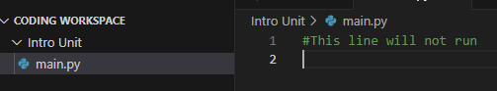

# Print Statements

* Print statements are used to **display something to the terminal**.
* They are written in the form (syntax) print("[string]"). Printing integers work, too: print([int]).
* Examples: 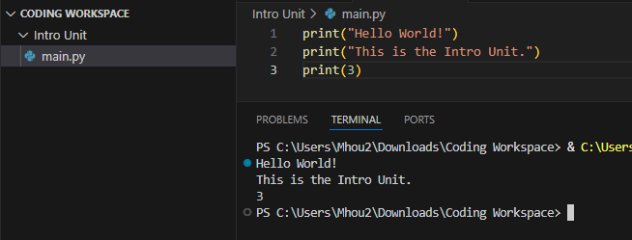

# 

# A Few Data Types

* Strings
  + 
* Integers
  + 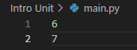
* Floats (basically decimals)
  + 

# Adding Strings (String Concatenation) and Adding Integers

* Strings can be **joined together**. The form (syntax) of this is: "[string1]"+"[string2]" which results in "[string1][string2]".
* Examples:
  + 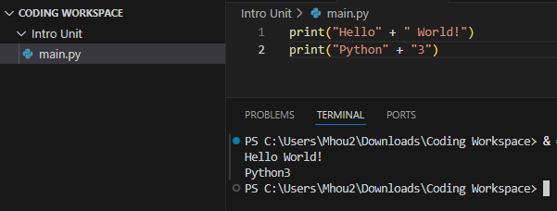
* Integers can be **added together**. The form (syntax) of this is: [int1]+[int2] which results in their sum [int3].
* Examples:
  + 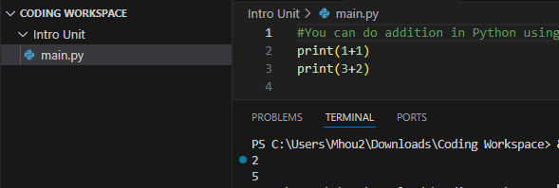
* **CAUTION!!** Two different data types **can NOT be added together**.
* Examples:
  + Correct method and incorrect method: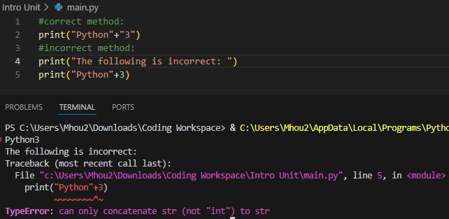

# Variables

* Variables are used to **store values**. They can be **any data type**.
* Variable names cannot start with a letter or an underscore. They can only contain alphanumeric (1, 2, a, b, A, B, etc.) characters and underscore.  
  **CAUTION!!** They are **case sensitive**!!.
* Examples:
  + 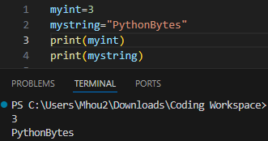
* **CAUTION!!** When concatenating (adding together) variables, make sure **they’re of the same data type**.
* Example:
  + 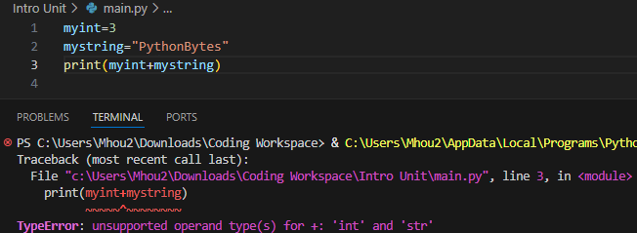

# Changing a Variable’s Data Type (Casting)

* Oftentimes, we want to be able to change the type of a variable to make it the same type as another variable.
* In class, we learned int("[string]") -> string and str([int]) -> int.
* Examples:
  + 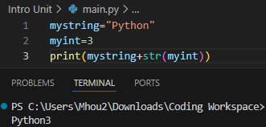
  + 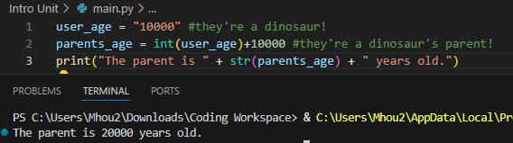
* This is especially useful when we do input().

# User Input

* This is how we **take input from the user**! The form (syntax) is similar to a print() statement: input("[string]"), but it allows the user to enter an input.
* To store the user input, **set the input equal to a variable.** 
* **CAUTION!!** The result is a string no matter what! Remember to **not mix up data types** especially when adding two variables together.
* Examples:
  + 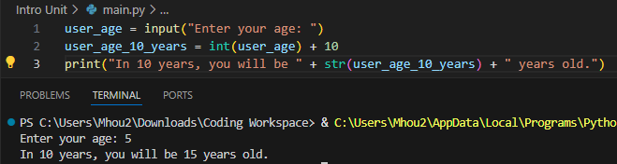

# Conclusions

Thank you students for showing up and participating! Look forward to lesson slides next time too! Additionally, thank you parents and volunteers :D See you next week!

Remember to bring a non-school laptop with VSCode and Python installed if possible, and for students, remember to **ask questions and answer questions** for **hichews** 🙂